AWS Assignment

Q1. Create a virtual network with 2 subnets. Each subnet should have 16 Ips only.

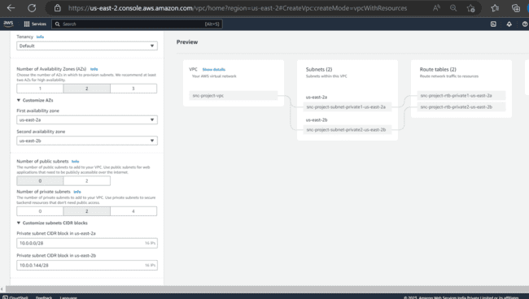

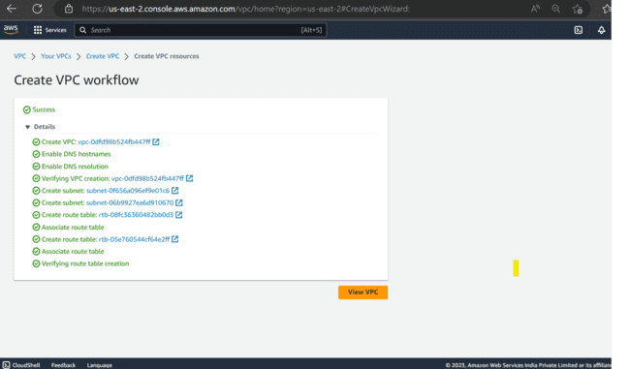

Q2. Inside one of the subnets, create a VM and deploy an application code inside it (any existing application created by you before). Make sure to use appropriate NACLs and SGs

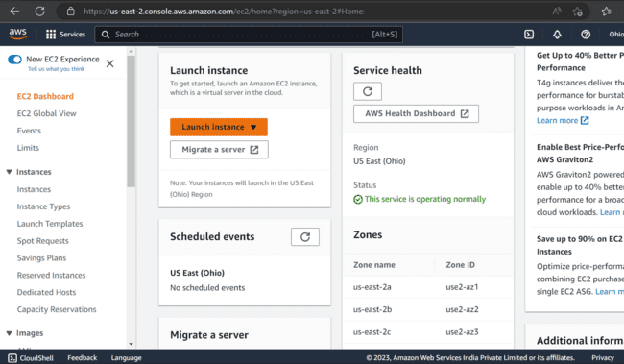

Q3. Deploy the same application to Elastic beanstalk Service.

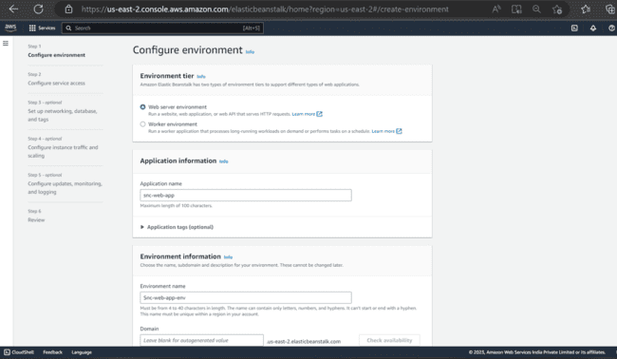

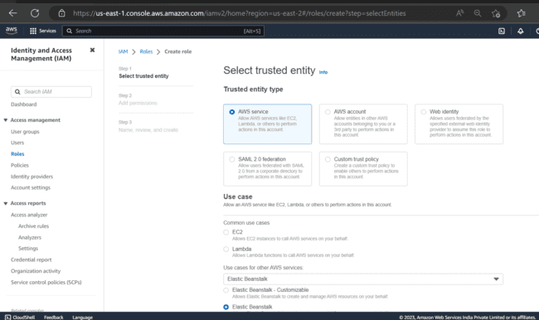

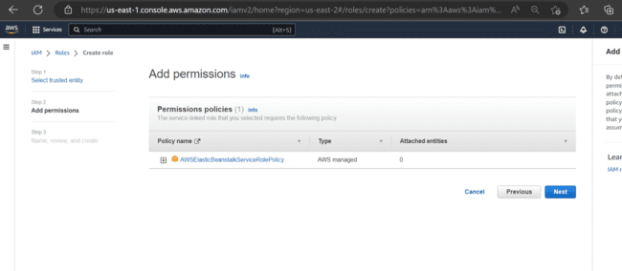

Q4. Create a Lambda that should trigger as soon as you upload a file in the S3 bucket.

Function should be able to print the name of the file uploaded in the function.

